Animal Sighting Tracker Part 2
Note: Before you start work today please take a few minutes to think about your priorities for the week and put them in your 1:1 doc (Remember it is OK if things change, this is not set in stone!)
Working with your Trio/Buddy: Last Picture Story
- Ask everyone to share the last photo they took
- Brief explanation of what's happening in the photo
- Enjoy the interesting glimpses into daily lives of your trio

SQL HAVING Clause
The HAVING clause was added to SQL because the WHERE keyword cannot be used with aggregate functions.

CSS Color Libraries
Color libraries are small CSS files containing commonly used color values like safety standards, highway colors, fashion colors, camouflage colors, and more.

BigO practice
Take a look at the provided screenshots. What do you think are the runtimes? For added practice take a look at the runtime analysis files here.

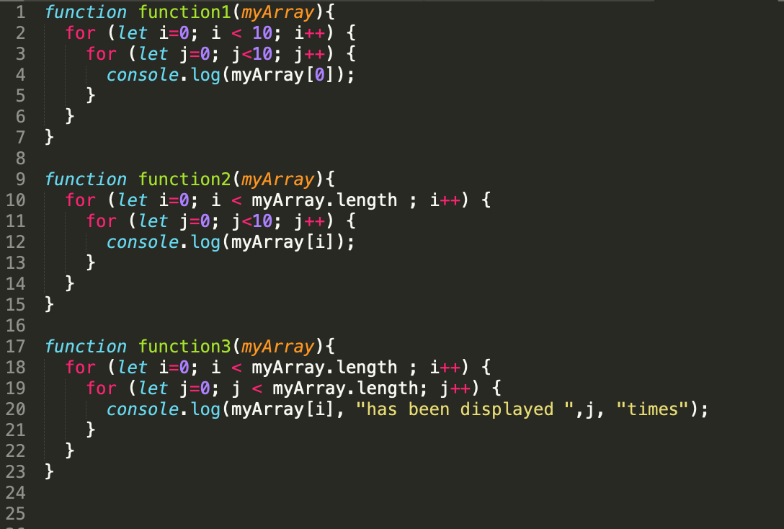

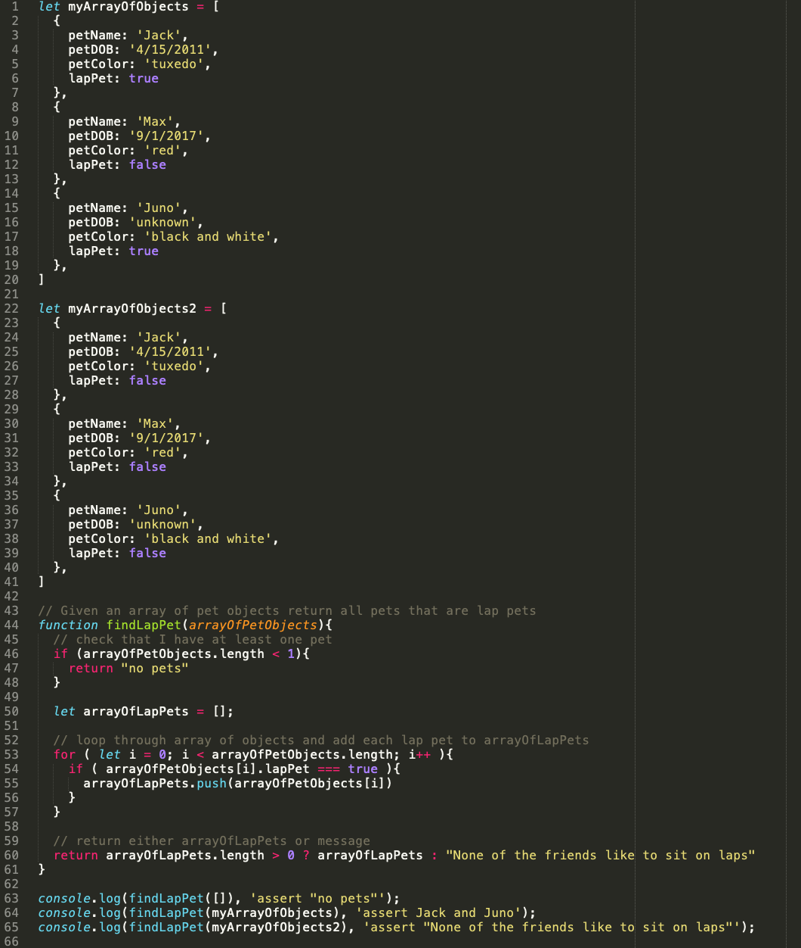

Quiz: Debugging, Git, & GitHub

